Anatomy & Physiology 12
Lab Safety | Name:  Block:  Date:

- Why might eating or drinking in the laboratory be dangerous?

- How can reading though the entire lab before beginning the procedure help prevent accidents?

- What safety equipment can be found around the lab?

- What safety procedures should you follow when cleaning up at the end of a lab?

- Can minor safety procedures be skipped in order to finish the lab before the bell rings?

- Draw a picture of the lab and show the location of the fire extinguishers, eyewash stations, fire blankets, and safety showers located in the lab.

- What kinds of measurements might you need to make in the lab? What kinds of equipment would you use for these measurements?

- Why are there several types of glassware marked for measuring?

- How might glassware be used differently?

- When might you need to use a thermometer in the lab?

- Describe the function of each piece of lab equipment in the picture below.
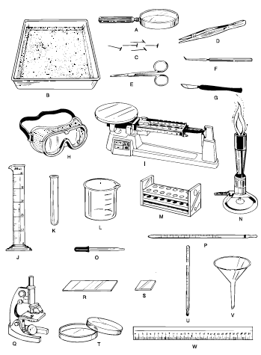

- Which laboratory tools can be used to magnify small objects so they can be seen more easily?

- Which laboratory tools are useful when looking at the internal organs of an earthworm?

- What tool(s) would you use to make each of the following measurements?
  - Amount of milk in a small glass

  - Length of a sheet of paper

  - Temperature of water in a swimming pool

  - Mass of a baseball

- How do lab equipment improve the observations made by a scientist?

