Anatomy & Physiology 12  Acid and Base Worksheet | Name:  Block:  Date:

- Define an acid.

- Define a base.

- Acids are molecules that dissociate in water, releasing __________ ions, __________ are molecules that either take up hydrogen ions or release hydroxide ions.

- pH is defined as the negative logarithm of the __________ ion concentration. As we move down the pH scale, each unit __________ times the acidity of the previous unit. A pH of __________ has an equal concentration of hydrogen ions and hydroxide ions.

- The pH scale ranges from 0 to __________. __________ are chemicals or combinations of chemicals that take up excess hydrogen ions or hydroxide ions and help keep the pH within normal limits.

- Label the following diagram of the pH curve with these terms: basic, acidic, neutral, hydrogen ion concentration, and hydroxide ion concentration.
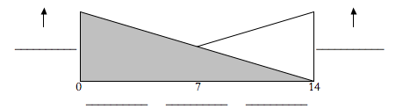

- Complete the following table to help understand the relationship between the hydrogen ion concentration and pH.

[H⁺] | pH | Acid/Base/Neutral
Example: 1 x 10⁻⁶ | 6 | Acid
1 x 10⁻⁵
1 x 10⁻¹⁰
1 x 10⁻⁷

- As the pH of a solution changes from 8.6 to 9.6, it becomes more __________ (acidic/basic). At a pH of 7, the number of hydrogen ions __________ the number of hydroxide ions. A pH of 6 has __________ times as much hydrogen ions as a pH of 8. The pH curve starts at __________ and goes to __________. As the pH of a solution increases, the number of hydrogen ions __________ (increases/decreases). As the pH of a solution increases, the number of hydroxide ions __________ (increases/decreases). __________ help to prevent any change in the blood pH.

