Life Science 11  Evolution: Comparative Morphology Lab | Name:  Date:  Block:

We will be investigating homologous structures by comparing limbs of a frog, human and a chicken.

Follow the directions below slowly and carefully – don’t rush through the dissection and make mistakes. Make your diagram as accurate as possible and label everything that you see in your drawing.

Pre-Lab

- How do we calculate actual size?

- How do we calculate drawing magnification?

- Describe what homologous structures are. Provide an example.

- Describe what analogous structures are. Provide an example.

- What are vestigial organs? Provide an example of a vestigial organ in the human body.

- What safety precautions should one follow when completing a dissection?

- What are the 6 types of bones we will be observing in this dissection?

Part 1: The Chicken Wing

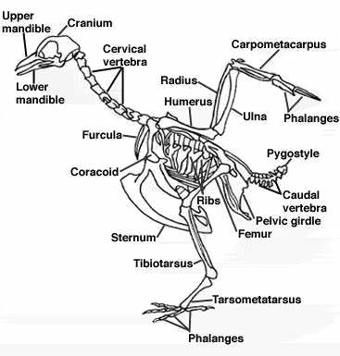

- Remove the skin from the chicken by slitting it with scissors and peeling it off. Be careful not to cut through any of the underlying muscles.

- Locate the blood vessels and snip it in half. What happened?

- The muscles of a chicken wing are very similar to those in a human arm. Identify the following: biceps, triceps, and forearm muscles.

- Find a muscle that moves the metacarpals. Remove as much fat from it as possible without actually cutting the muscle.

- Snip the tendon as close to the humerus as possible. Pull on the tendon that is still attached to the metacarpals to observe the movement of the end of the wing.

- Remove all of the muscles and tendons, leaving only the bones and the ligaments.

- Draw the wing bones of a chicken and label the: humerus, ulna, radius, carpals, metacarpals, and phalanges. Colour each bone a different colour. Include actual size and drawing magnification.

Actual Size: ______
Drawing Size: ______
Drawing Magnification: ______
Part 2: The Frog & Human Arm Comparison

In the chart below, draw the arm bones of both a frog and human. Be sure to label the following: humerus, ulna, radius, carpals, metacarpals, and phalanges. Colour each bone the same colour you coloured them in the chicken wing. (ex. The humerus will be the same colour in both drawings).

Frog Arm | Human Arm

Discussion Questions

- How many bones did you find in each of the limbs?

- Look at your colour-coded drawings. How are the bone structures of the chicken wing, frog arm, and human arm similar?

- Look at your colour-coded drawings. How are the bone structures of the chicken wing, frog arm, and human arm different?

- Fill in the table below.

Organism | Structure | Function
Chicken

Frog

Human

- Do the three structures perform the same function? Why do you think this is?

- How do you think the internal structures of these three forelimbs could be so similar?

- What does this tells us about the relationship between chickens, frogs, and humans?

- How is this evidence for evolution?

