Biology 11  Microbiology Review | Name:  Date:  Block:

Unit test will be on Viruses, Immune System and Bacteria. Test will be comprised of multiple choice, matching and short answer questions.

Viruses

- Examine the image of a typical bacteriophage (virus that infects bacteria). Identify each part of the virus and describe its function.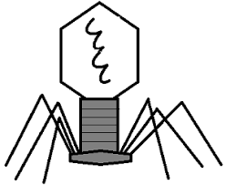

- With the aid of a diagram, describe the steps of the lytic life cycle of infection.

- With the aid of a diagram, describe the steps of the lysogenic life cycle of infection.

- With the aid of a diagram, describe the steps of the lytic and lysogenic life cycles of infection.

- Compare and contrast the lytic and lysogenic life cycles of infection.

- Describe why a virus is not considered to be living.

- What is a retrovirus? Provide and example.

Bacteria

- Label the parts of the bacteria below and indicate the function of each part.

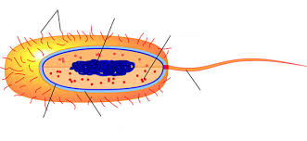

- Use a diagram to explain the process of reproduction in bacteria. This process is called: _____________________

- Use a diagram to explain the process of how bacteria diversify. This process is called: _____________________ Be sure to include the following terms: donor bacterium, recipient bacterium, plasmid, cytoplasmic bridge.

- What is an Endospore? How does it form?

- List three shapes of bacteria (scientific name) and draw them.

- What is the difference between autotroph and heterotroph? Chemotroph and phototroph?

- List some benefits of bacteria.

- List some harmful aspects of bacteria.

- How do bacteria cause disease?

- Explain the difference between gram-positive and gram-negative bacteria.

- What is the Germ Theory of Infectious Disease?

- Describe Koch’s postulates (in the correct order)

Immune System

- What is a pathogen?

- How does the first line of defense work to protect our bodies?

- How does the second line of defense work to protect our bodies?

- How does the third line of defense work to protect our bodies?

- How does your body become immune to certain infections? Think about memory cells and vaccines.

