Science 8  Atomic Theory Practice Test | Name:  Date:  Block:

- What is an element?

- Classify the following as an element, compound or mixture:

Fluorine: ___________________  Sandwich: ___________________  Coffee: ___________________ | CO₂: ___________________  Water: ___________________  Computer: ___________________

- What is the lightest element?

- Which family is the following element a part of?

Radium: ___________________  Sodium: ___________________  Mg: ___________________  Neon: ___________________ | I: ___________________  Xenon: ___________________  Nickel: ___________________  Ba: ___________________

- What is an atom?

- Give three examples of elements in substances or objects that you use:

- How is the Periodic Table organized?

- What is one property/characteristic of alkali metals?

- What does the atomic number represent?

- What does the atomic mass measure?

- What are the three subatomic particles?

- Complete the following table:

Subatomic Particle | Charge | Location in the atom | Mass
 | neutral
 | negative
 | positive

- Determine the subatomic particle(s) described by the following statements:
- Has a charge: ___________________ and ___________________
- Has the heaviest mass: ___________________ and ___________________
- Does not have a charge: ___________________
- Has the lightest mass: ___________________
- Is found in the nucleus: ___________________ and ___________________
- Has equal masses: ___________________ and ___________________
- Gives the nucleus a positive charge: ___________________
- Is found in shells that surround the nucleus: ___________________
- Have equal quantities in all neutral atoms: ___________________ and ___________________

- Why does the nucleus of an atom have a positive charge?

- Where is most of the volume found in the atom? Explain with your answer with a diagram.

- Use the periodic table below to help answer these questions:
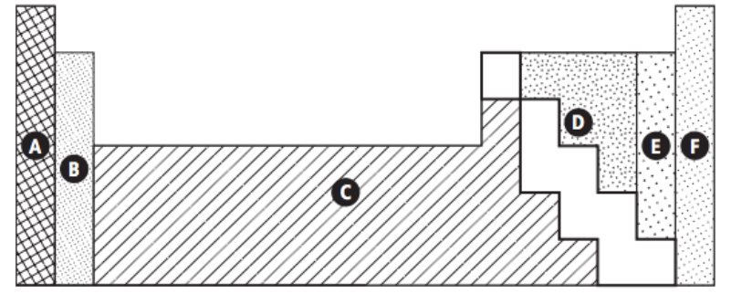

- Argon: _________  - Sulfur: _________  - Silver: _________  - Tungsten: _________  - Alkaline Earth Metals: _________ | - Calcium: _________  - Most reactive metals: _________  - Least reactive: _________  - Halogens: _________  - Transition metals: _________

- Complete the following table:
Element Name | Element Symbol | Atomic Number | Atomic Mass | # of protons | # of neutrons | # of electrons
 | Ti
 |  | 35
 | Au
 |  |  |  |  |  | 83
 |  |  |  |  | 8

- What does a Bohr model represent?

- In a Bohr Diagram, what is the maximum number of electrons allowed in the:

  - Innermost (first) shell? __________

  - Second shell? __________

  - Third shell? __________

- Identify the element represented by the following Bohr Diagram:

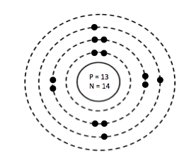 | 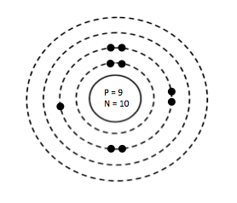
Element: | Element:
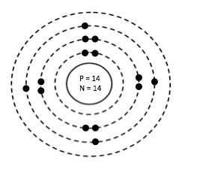 | 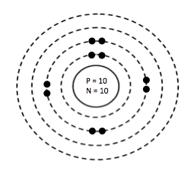
Element: | Element:

- Draw the Bohr diagram for the following elements:
Lithium  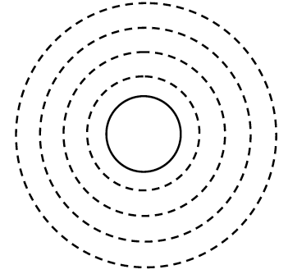 | Neon | Calcium
Chlorine | Argon | Sulfur

