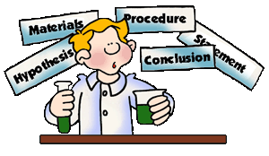 | Science 8  Scientific Method | Name:  Date:  Block:

PURPOSE

RESEARCH

HYPOTHESIS

EXPERIMENT/PROCEDURE

ANALYSIS

CONCLUSION

Sometimes before we even start an experiment, we have to OBSERVE what is around us.
Observations can (in general) be divided up into:

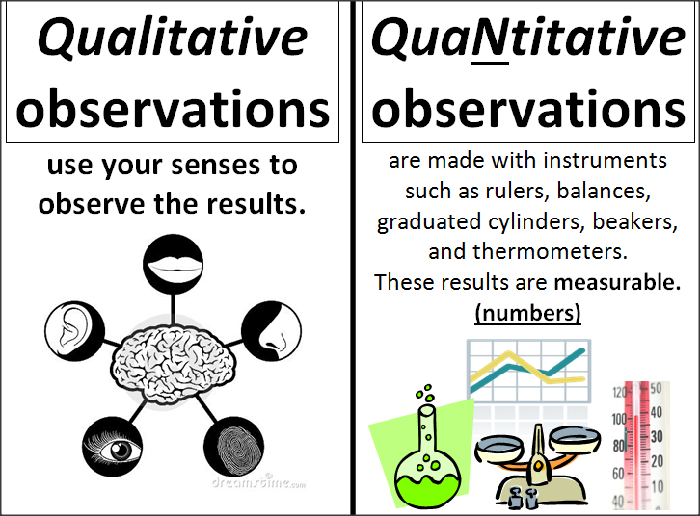

I am making an observation about…
Qualitative Observations | Quantitative Observations

I am making an observation about…
Qualitative Observations | Quantitative Observations

