Science 8  Changes in States of Matter | Name:  Date:  Block:

What have we learned so far? Turn to the person next to you and share 3 things!

Kinetic Energy (KE) is the energy of ________________________.
Adding Energy | Removing Energy
- Particles move _________________. | - Particles move _________________.
- The space between the particles _________________. | - The space between the particles _________________.
- Particles cover ________________ area. | - Particles cover ________________ area.
- The material ________________ in volume. | - The material ________________ in volume.
- Called: | - Called:

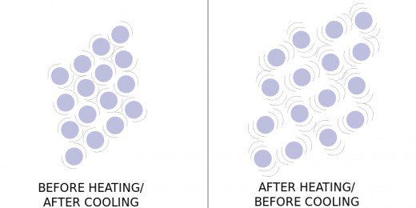

Can you use the concepts of thermal expansion and contraction to explain how a thermometer works?
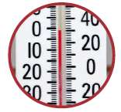

Sometimes enough energy is added or removed to completely CHANGE the state!

For each arrow, indicate:  - The name of change of state using the word bank  - Whether heat is gained (+) or lost (-) | Word Bank:  - Condensation  - Deposition  - Evaporation  - Melting  - Solidification  - Sublimation

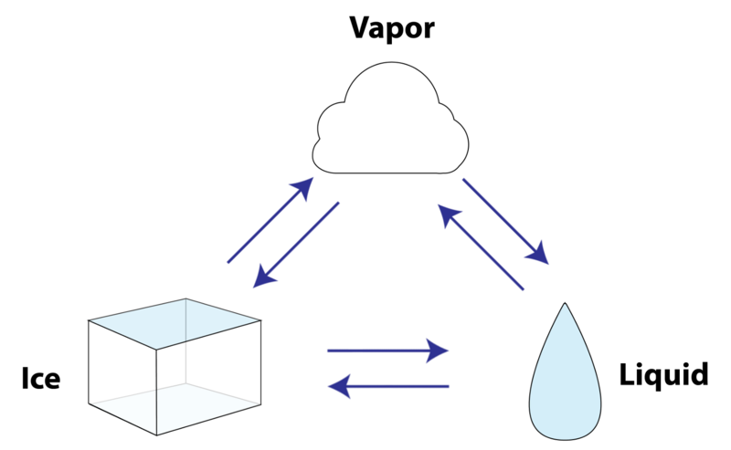
Provide an example for each of the changes of state:
Condensation: | Solidification: | Sublimation:
Evaporation: | Melting: | Deposition:

Some more definitions…
Melting Point:

- The melting point of water is:

Boiling Point:

- The boiling point of water is:

☐ Worksheet

