Science 8  Controlled Experiments | Name:  Date:  Block:

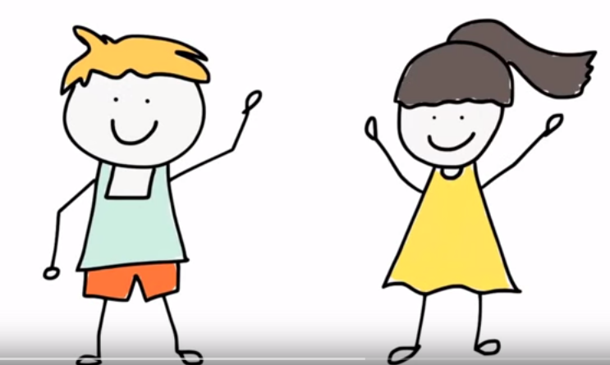 https://www.youtube.com/watch?v=VhZyXmgIFAo

Mark Molly

Whose plant do you think will grow more? Why?
I predict that…

Because…

What were the results?

What is wrong with the experimental design?

What would you do to change the experimental design?

Independent Variable:
- Definition:

Dependent Variable:
- Definition

Consider this scenario…
Nadia has brown wavy hair and Tiana has brown straight hair. Nadia uses Pantene Pro-V conditioner and Tiana uses Dove conditioner. After 2 weeks, Tiana has shinier hair.

- Is this a controlled experiment? Why or why not?

- How would you redesign this experiment to make it controlled?

- Identify the independent and dependent variable in your redesigned experiment:
  - Independent:

  - Dependent:

