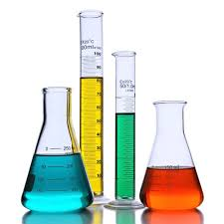  Science 8  Equipment In The Lab! | Name:  Date:  Block:

Station 1: Using A Scale

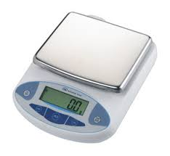
- What do you think a scale is used to measure?

- In the picture to the right, circle and label the “on/off” button.

- Turn on the scale. What does the screen display? _____________

- On the bottom right of the screen, what is the unit displayed? Circle one of the following:

ct oz lb g

- In Canada, the SI Unit grams (g) is used to measure mass. In the picture to the right, circle and label the button used to change the unit to grams.

- Ensure that the scale displays “g” as your unit.

- Before you measure the mass of the provided object, what should your scale read? _____________

- Hit the “tare/zero” button on your scale so that it reads 0.0 g.

- Pick up the provided object and place on the scale. The mass of the object is _____________.

- Turn off the scale.

Station 2: Determining Mass By Subtraction

- Turn on and tare/zero the scale provided. Ensure that the scale reads 0.0 g.

- Take an empty beaker and measure the mass. Record the mass in the data table below.

- Carefully pour approximately 20 mL of the provided chemical into the beaker.

- Measure the mass of the beaker with the chemical. Record the mass in the data table below.

- Using subtraction, what is the mass of 20 mL of the chemical? Record your answer in the data table below.

- Carefully return the chemical to the waste bucket and turn off the scale.

Data Table
Mass of Empty Beaker
Mass of Beaker with Chemical
Mass of Chemical

Station 3: Using A Ruler

- Measure the width and length of the rectangle below to one decimal place. What unit should recorded?

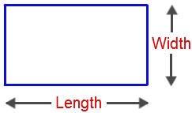 | 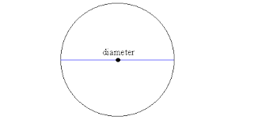
Width: _____________  Length: _____________ | Diameter: _____________

- There are three objects at your stations. Measure the dimensions of each item. Make sure to include proper units!

Metal strip | Circular mirror | Wooden Block
Width: _____________  Length: _____________ | Diameter: _____________  Thickness: _____________ | Width: _____________  Length: _____________  Height: _____________

Station 4: Measuring Volume
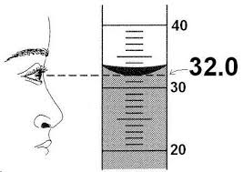
- Observe the picture to the right. The curved line is called the
meniscus. The reading must be taken from the bottom of the
meniscus.

- What unit should the data be recorded in? Circle one of the following.
mL kg g km

- Take the reading of the following to one decimal place. Make sure to include proper units!

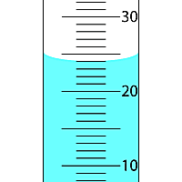 | 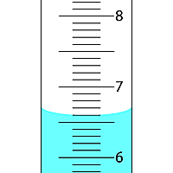 | 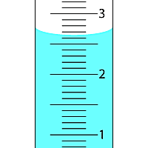
Volume: _____________ | Volume: _____________ | Volume: _____________

- There are three graduated cylinders at your station. Take the reading of each one to one decimal place. Make sure to include proper units!

Graduated Cylinder #1
Graduated Cylinder #2
Graduated Cylinder #3

Station 5: Using A Thermometer

- There are two beakers at your station. Label the beakers A and B.

- Fill one beaker with cold water from the tap and the other beaker with hot water from the kettle. Label which beaker is cold and hot in the table below.

- Take the thermometer and put it in the cold beaker. Record the temperature in the table below.

- Take the thermometer and put it in the hot beaker. Record the temperature in the table below.

- Add a drop of food colouring in each beaker. Wait for approximately 1 minute.

- After waiting for 1 minute, draw what you observe in the beaker in the table below.

- Write down any changes you observed over the 1 minute in the table below.

Beaker A  _____________ water  Temperature: ________________ ºC | Beaker B  _____________ water  Temperature: ________________ ºC
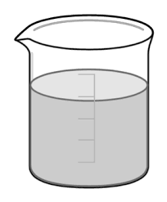
Observations:  -  -  - | Observations:  -  -  -

- Pour all the water from the beaker carefully down the sink.

Station 6: Measuring Angles

Using the provided protractor on the table, measure the following angles:

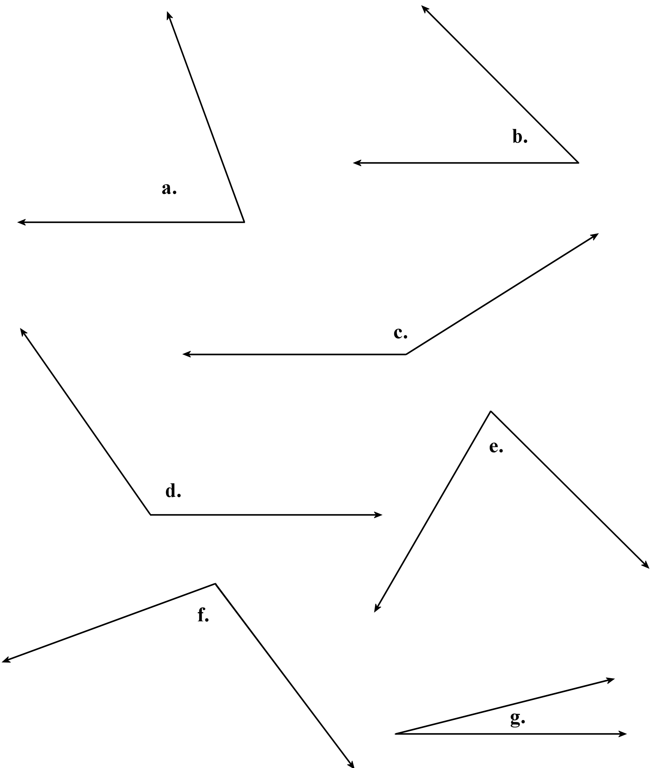 | - __________________  - __________________  - __________________  - __________________  - __________________  - __________________  - __________________

Station 7: Mix and Match

Using the provided equipment on the table, match the equipment with the names below:
_________ 1. Beaker  _________ 2. Thermometer  _________ 3. Erlenmeyer flask  _________ 4. Hot plate  _________ 5. Test tube  _________ 6. Test tube rack  _________ 7. Scale | _________ 8. Graduated cylinder  _________ 9. Eyedropper  _________ 10. Safety glasses  _________ 11. Bunser burner  _________ 12. Scoopula  _________ 13. Stir rod  _________ 14. Funnel

Station 8: Scenarios

a) Beaker  b) Thermometer  c) Erlenmeyer flask  d) Hot plate  e) Test tube  f) Test tube rack  g) Scale | h) Graduated cylinder  i) Eyedropper  j) Safety glasses  k) Bunser burner  l) Scoopula  m) Stir rod  n) Funnel

This piece of equipment is used…

_________1. To protect your eyes.

_________2. To measure the temperature of a liquid.

_________3. For approximate measurement of a liquid.

_________4. For more accurate measurement of a liquid.

_________5. To measure the mass of a substance.

_________6. To hold a test tube.

_________7. To transfer small amounts of liquid from one container to another.

_________8. To stir liquids.

_________9. To scoop solids.

_________10. To transfer liquids into a container with a small opening.

