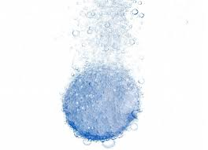  Science 8  Antacid Reaction Challenge! | Name:  Date:  Block:

As a class, brainstorm some questions about antacid tablet reaction speeds that can be answered by using the scientific method.

With your group, choose ONE of the questions to study!

QUESTION
My question is:

HYPOTHESIS
My hypothesis is:

Independent Variable: Dependent Variable:

EXPERIMENT

MATERIALS:

- Two beakers

PROCEDURE:

- Put on safety goggles.

RESULTS

BEFORE the experiment:

Tablet A: ______________ | Tablet B: ______________
Qualitative:  Quantitative: | Qualitative:  Quantitative:
Liquid A: ______________ | Liquid B: ______________
Qualitative:  Quantitative: | Qualitative:  Quantitative:

DURING the experiment:

Beaker A | Beaker B
Qualitative: | Qualitative:

AFTER the experiment:

Beaker A | Beaker B
REACTION TIME: | REACTION TIME:
Qualitative:  Quantitative: | Qualitative:  Quantitative:

ANALYSIS

Find another group that had the same research question as your group. Compare their results to your group’s results by completing the table below.

 | Beaker A Reaction Time | Beaker B Reaction Time
My group’s results:
Another group’s results:

CONCLUSION

In your conclusion, write a paragraph describing:
- your findings
- the effect of your independent variable on the reaction time
- whether your hypothesis was confirmed or rejected
- any variables that could have affected your results
- what you would do differently if you were to perform this experiment again

