Science 8  Microscope Practice Quiz | Name:  Date:  Block:

Try answering the following questions without using your notes!

- List the seven characteristics of living things and give an example of each.

- Label the compound microscope. Use the word bank to help you.
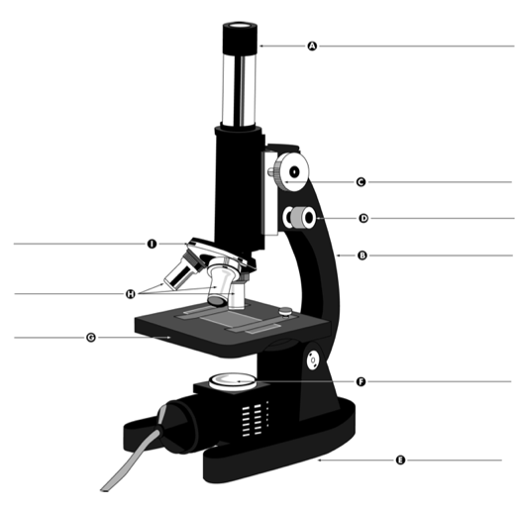
Choices

arm objective lenses light source
revolving nose piece fine focus knob base
stage eyepiece coarse focus knob

- What is the magnification of the eyepiece? _________

- What is the magnification of the…
  - low power objective lens? _________
  - medium power objective lens? _________
  - high power objective lens? _________

- If you magnify an object using the low power objective lens, what is the total magnification?

- Which objective lens would you use to magnify an object…
  - 400x? _____________________________
  - 100x? _____________________________

- What is the field of view?

- Explain what happens to the field of view if you change from the high power objective lens to the low power objective lens.

