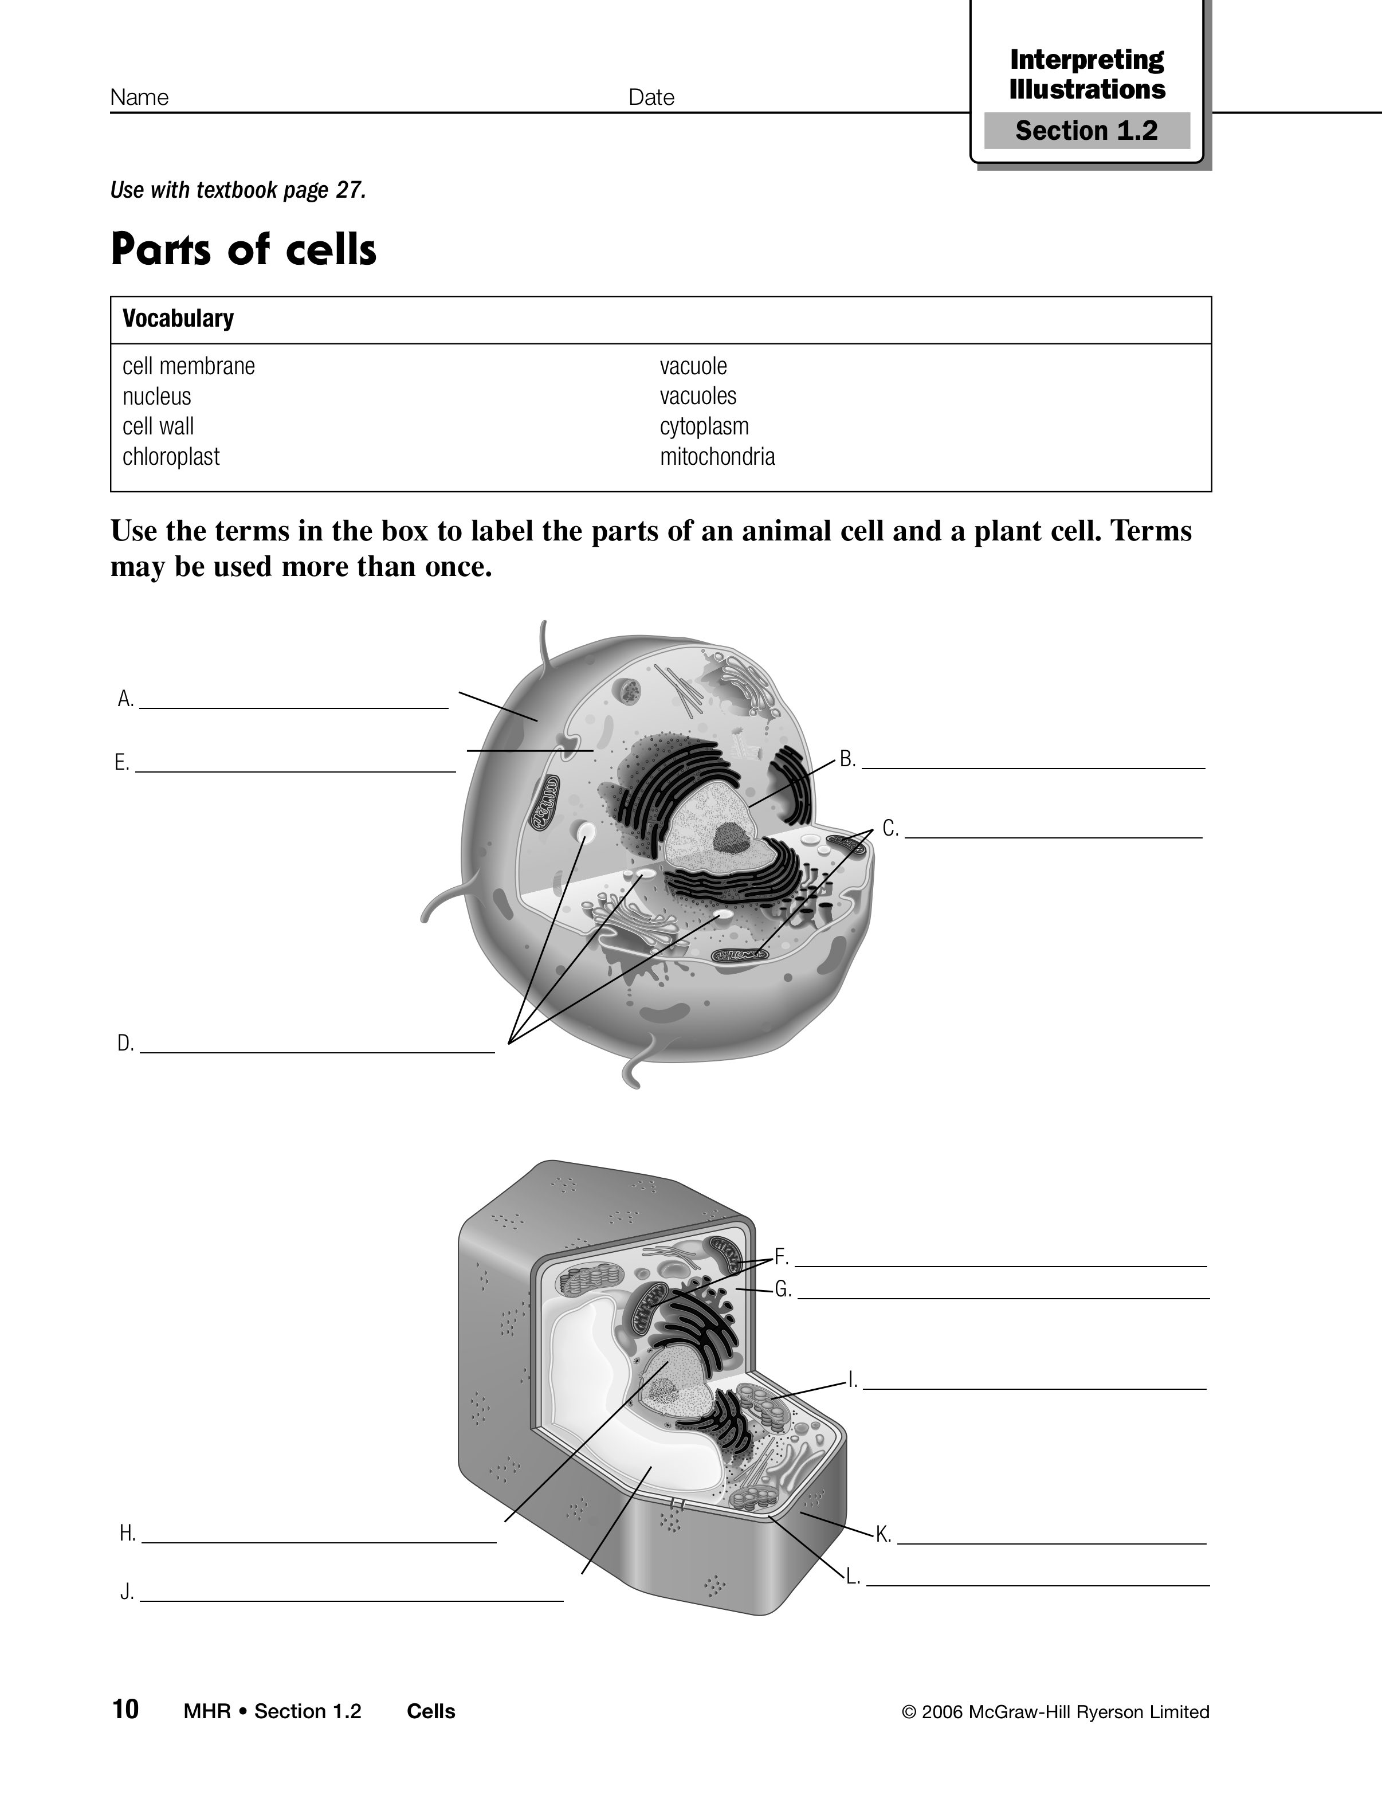

Science 8
Organelles

- In your own words, state the definition of organelle and provide an example.

- Which organelle is the control centre of the cell? Explain why.

- Which structure protects both types of cells?

- What is the other function of the organelle in question 3?

- What does the process of cellular respiration provide for the cell? What organelle is responsible for this?

- Why do plants do photosynthesis? What organelle is responsible for this?

- How do plant cells differ from animal cells?

