Science 8  Cells | Name:  Date:  Block:

There are two types of cells:

Why study cells?
- Cells Tissues Organs Bodies
  - Our bodies are made up of __________________.
  - Cells are the __________________________________.

The Jobs of Cells

Cells have 3 main jobs:

Organelles

- There are different structures ( ___________________) that carry out the three main jobs.
- Organelles are like the cell’s ________________.
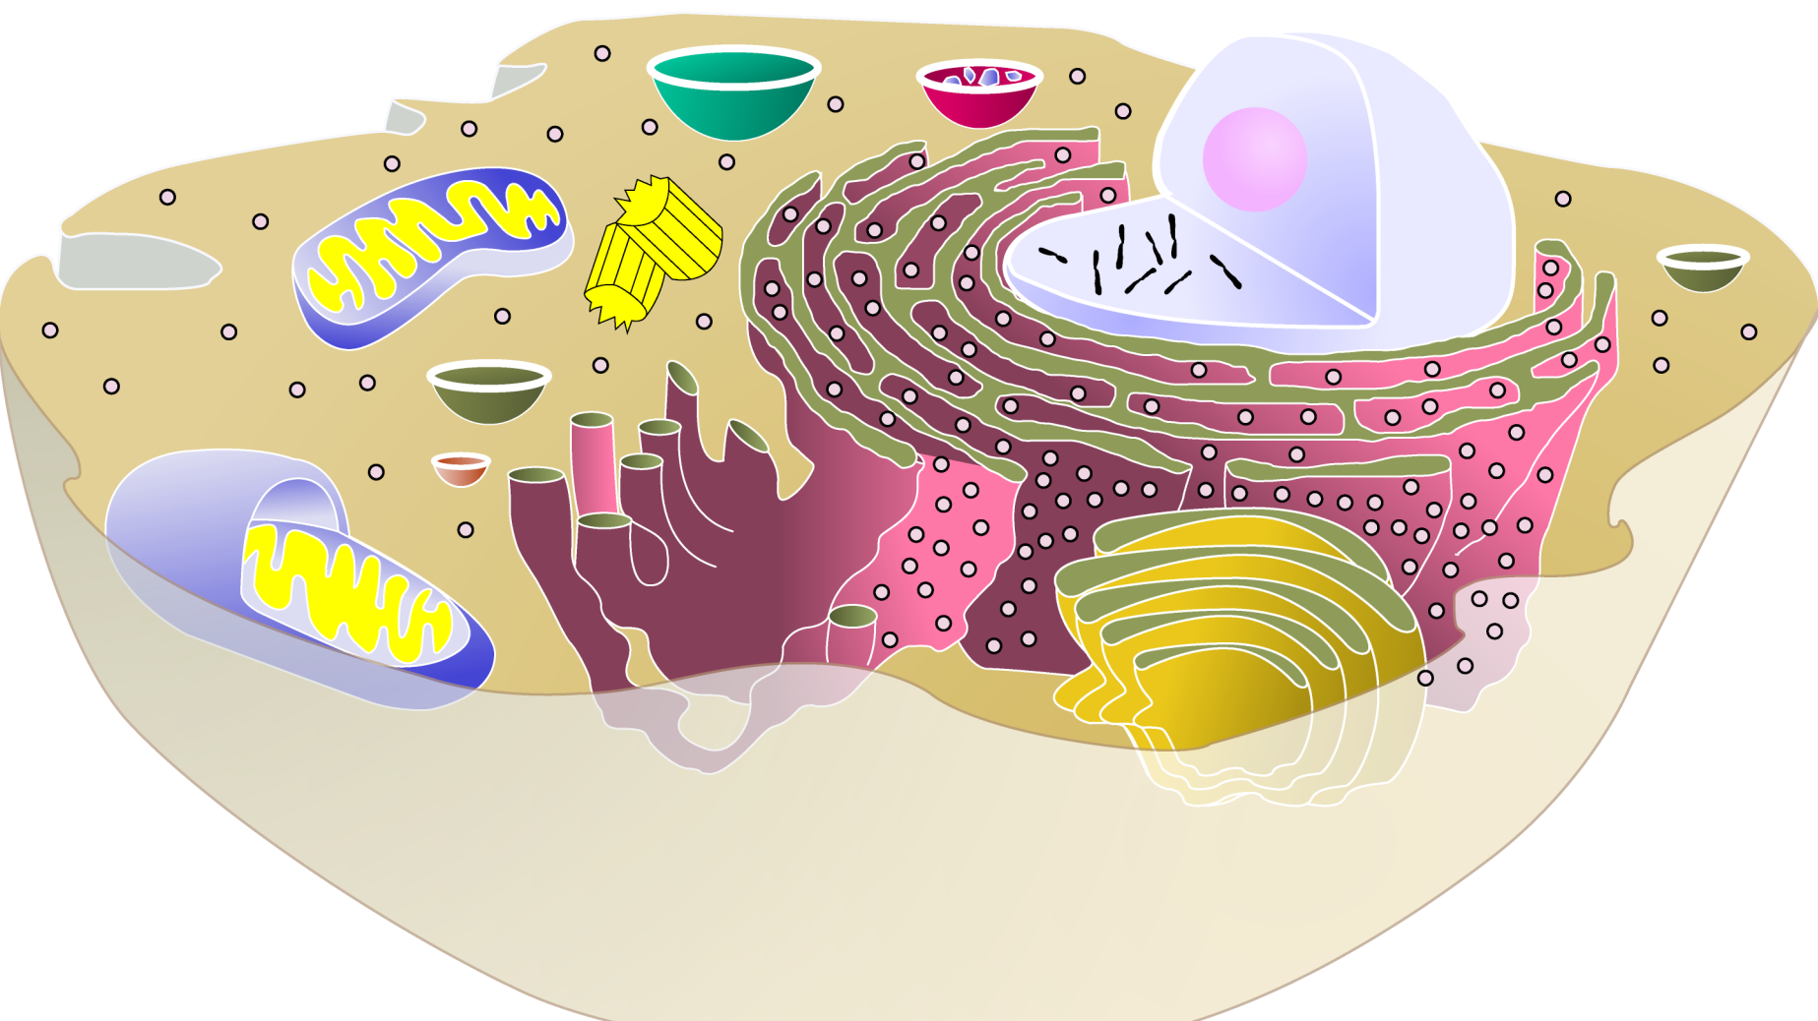
- Organelle = ____________________________
- Everything in the cell is an organelle except for the ____________________________.

Cytoplasm
- Jelly-like substance
- Maintains the structure of the cell
- Contains __________________, and _____________________________________.

Cell membrane
- Boundary of the cell
- Controls movements _______ and ______ of the cell.

Nucleus
- Control center of the cell,.
- Contains genetic material called _____________.
- Usually the easiest organelle to see under the microscope.
- Usually one per cell

Job #1 : Produce energy

Mitochondria
- Powerhouse of the cell.
- ____________________ __________________ occurs here to release energy for the cell to use
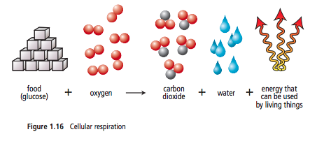

Job #2 : Make proteins

Ribosomes
- Small particles that makes ____________________
- Found floating free in cytoplasm or attached to ___________________ ______________________.

Endoplasmic Reticulum
- Highway of the cell
- Connected to _______________ around the _____________________.
- Proteins pass through the _____________________ ___________________ to the ________________________.

Golgi Body
- Looks like a stack of plates
- _______________, ____________________ and ___________________ proteins.
- Proteins are transported to and from the Golgi body by __________________.

Vesicles
- Vesicles function like a ___________________________.
- Carry _______________, _______________ and ________________ in and out of and around the inside of the cell.

Job #3 : Eliminate waste

Vacuoles
- Storage container for _____________, _______________, ______________ etc.
- Larger in plant cells

Lysosomes
- ______________ _______________ of the cell
- Contain digestive enzymes that _______________ _______________ wastes.

Differences Between Plant and Animal Cells

Cell Wall
- Found in _______________ and _______________ cells
- Rigid, protective barrier
- Located _______________ of the cell membrane

Chloroplasts
- Found only in ______________ cells
- Contains the green pigment ______________________.
- Site of food production during _____________________________.

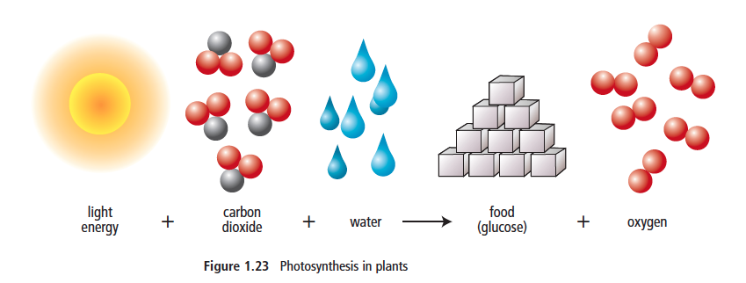

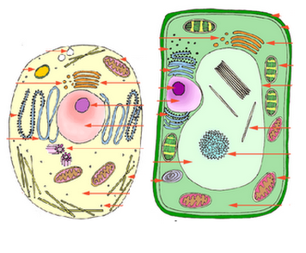
Vacuoles
- Bigger in _______________ cells than in _______________ cells.

