Chemistry 11  Organic Chemistry II Check Point  - Naming & Drawing Alkenes | Name:  Date:  Block:
Name the following hydrocarbons:

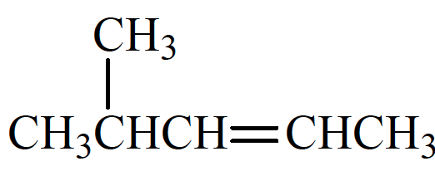 | _______________________________
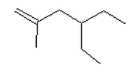 | _______________________________
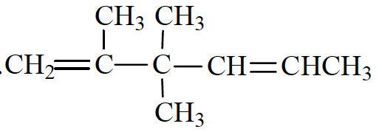 | _______________________________

Draw the following hydrocarbons:

2-methyl-1-pentene

4-ethyl-4-propyl-2-nonene

2,3,4-trimethyl-1-heptene

Chemistry 11  Organic Chemistry II Check Point  - Naming & Drawing Alkenes | Name:  Date:  Block:
Name the following hydrocarbons:

_______________________________
_______________________________
_______________________________

Draw the following hydrocarbons:

2-methyl-1-pentene

4-ethyl-4-propyl-2-nonene

2,3,4-trimethyl-1-heptene

