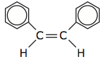 |  | Cycloalkanes |  | Name:  Date:
1. | 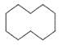
2. | 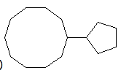
3. | 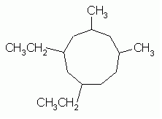
4. | 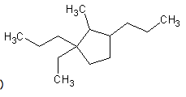
5. | 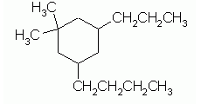
6. | 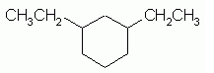
7. | 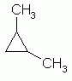

Draw the condensed structural formula for the following organic compounds:

- 1,3-dipropylcyclobutane
- cyclopentane
- 3-ethyl,1,1,3-tripropylcyclobutane
- 1,2-dimethylcyclopropane
- 1,3-dipropylcyclodecane
- cyclodecane 2) 1-cyclopentylcyclodecane 3) 1,3-diethyl-5,7-dimethylcyclononane 4) 1-ethyl-2-methyl-1,3-dipropylcyclopentane 5) 3-butyl-1,1-dimethyl-5-propylcyclohexane 6) 1,3-diethylcyclohexane 7) 1,2-dimethylcyclopropane 8-12) see website

